**Factor Construct in Database:**

After setting up the database,we run ***FactorConstruct/db/FactorConstruct.py*** to dump factors to database.

**How to Run Life Production?**

<1> Direct to the folder ***PortfolioConstruction/code_and_data***.

<2> Put the necessary data for review and capping dates in folder ***inputs***, as two csv files.

<3> Open the ***config_prd.json***, fill those hyper-parameters (containing database directory, review and capping dates, universe name, index name …) and parameters (parameters needed for the rebalancing process) at our will.

<4> Open the Python code ***run_lifeProduction.py***, as we can see below: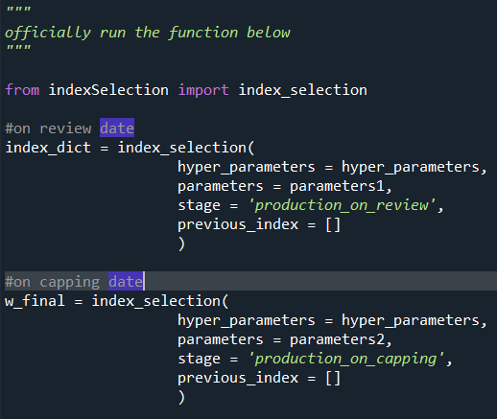

If we want to conduct review, we just run the part under *#on review date* and simply comment out the part below *#on capping date*.

Similarly, if we want to conduct rebalancing on capping date, we just run the part under *#on capping date* and simply comment out the part below *#on capping date*.

Note that the csv files will be generated for both *#on review date* and *#on capping date*. They are saved as ***output_for_review.csv*** and ***output_for_capping.csv*** in the folder ***outputs***.

**How to Run Back-testing?**

<1> Direct to the folder ***PortfolioConstruction/code_and_data***.

<2> Open the ***config_backtesting.json***, fill those rebalance dates, data dates, hyper-parameters (containing database directory, universe name) and parameters (parameters needed for the rebalancing process) at our will.

<3> Open the Python code ***run_backtesting.py***, as we can see below:

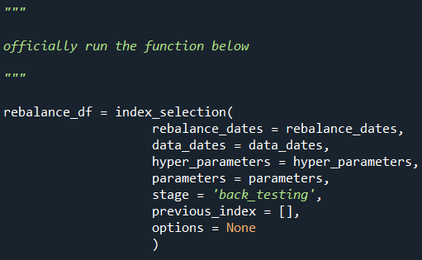

The output is the rebalancing data frame for back-testing, and it will be saved as ***output_for_backtesting.csv*** in the folder ***outputs***.